1. Add friend functions for the previous program. Write a C++ program to

create a class called COMPLEX and implement the following overloading

functions ADD that return a COMPLEX number.

                        i. ADD (a, s2) – where a is an integer (real part) and s2 is a

complex number.

                        ii. ADD (s1, s2) – where s1 and s2 are complex numbers.

#include <iostream>

using namespace std;

class Complex

{

private:

int x,y;

public:

Complex(int x_=0,int y_=0): x(x_), y(y_){}

void get();

friend Complex add(int a, Complex s2);

friend Complex add(Complex s1, Complex s2);

void print();

};

void Complex::get()

{

cout<<"Enter the real part and imaginary part of a Complex number : ";

cin>>x>>y;

}

Complex add(int a, Complex s2)

{

Complex c(s2.x + a, s2.y);

return c;

}

Complex add(Complex s1, Complex s2)

{

Complex c(s1.x + s2.x, s1.y + s2.y);

return c;

}

void Complex::print()

{

cout<<x<<" + i"<<y<<endl;

}

int main()

{

Complex c1;

c1.get();

int a;

cout<<"Enter a value to add it the real part : ";

cin>>a;

Complex c2 = add(a, c1);

cout<<"The Complex number after adding the real part is : ";

c2.print();

Complex c3 = add(c1, c2);

cout<<"Addition of two Complex numbers : "<<endl;

cout<<" ";

c1.print();

cout<<" + ";

c2.print();

cout<<" = ";

c3.print();

return 0;

}

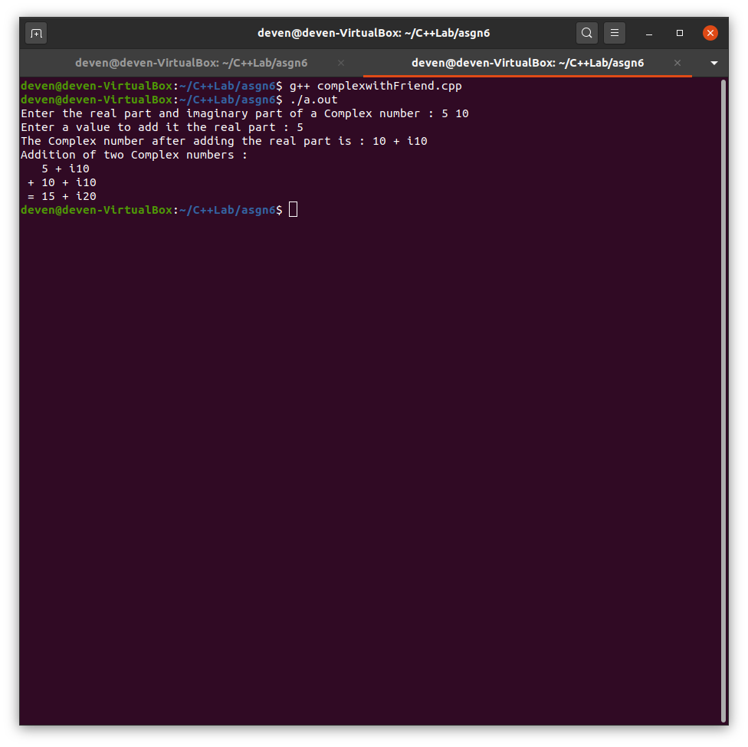

2. Write a program to find the transpose of a matrix using friend function and

with member functions to read and display the matrix.

#include <iostream>

using namespace std;

class matrix

{

private:

int m,n;

int a[3][3];

public:

matrix(): m(3),n(3){}

void read();

friend matrix findTranspose(matrix);

void display();

};

void matrix::read()

{

cout<<"Enter the elements of the matrix of order "<<m<<" x "<<n<<" : "<<endl;

for(int i=0;i<m;++i)

{

for(int j=0;j<n;++j)

{

cin>>a[i][j];

}

}

}

matrix findTranspose(matrix A)

{

matrix TA;

for(int i=0;i<A.m;++i)

{

for(int j=0;j<A.n;++j)

{

TA.a[j][i] = A.a[i][j];

}

}

return TA;

}

void matrix::display()

{

cout<<"The matrix is : "<<endl;

for(int i=0;i<m;++i)

{

for(int j=0;j<n;++j)

{

cout<<a[i][j]<<" ";

}

cout<<endl;

}

cout<<endl;

}

int main()

{

matrix A;

A.read();

A.display();

matrix TA = findTranspose(A);

cout<<"Transpose : "<<endl;

TA.display();

return 0;

}

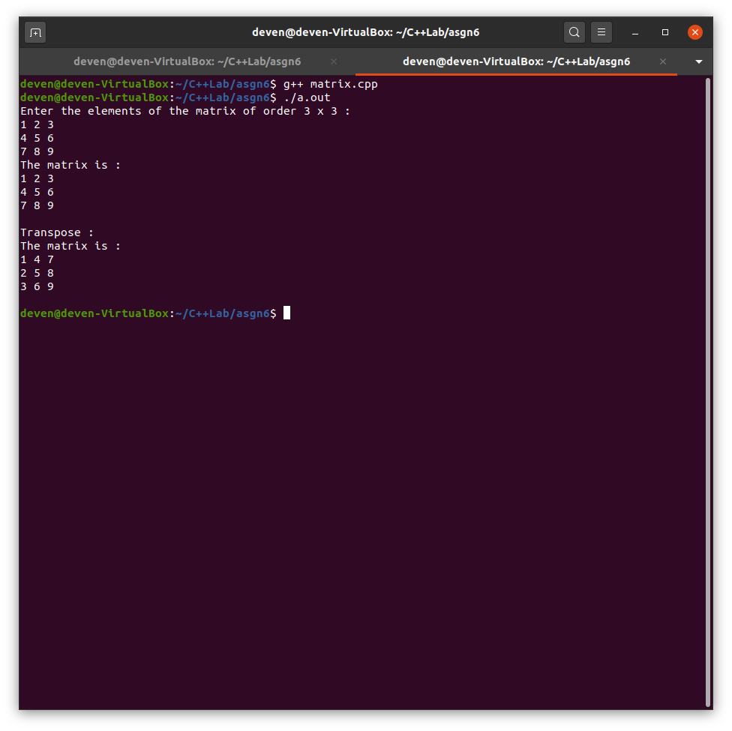

3. Prepare a class Student with suitable attributes and member functions. Add a friend function Predict to print the grade for a course.

#include <iostream>

using namespace std;

class student

{

private:

int id;

string name;

int marks[4];

public:

void read();

void display();

friend void predictGrade(student);

};

void student::read()

{

cout<<"Enter the student's id and name : "<<endl;

cin>>id>>name;

cout<<"Enter the 4 courses marks : "<<endl;

for(int i=0;i<4;++i)

cin>>marks[i];

}

void student::display()

{

cout<<"Student details : "<<endl;

cout<<"Id : "<<id<<endl;

cout<<"Name : "<<name<<endl;

cout<<"Marks in the 4 courses : "<<endl;

for(int i=0;i<4;++i)

cout<<marks[i]<<" ";

cout<<endl;

}

void predictGrade(student s)

{

for(int i=0;i<4;++i)

{

cout<<"Grade of course "<<i+1<<" : ";

if(s.marks[i]>=90)

cout<<"S"<<endl;

else if(s.marks[i]>=80)

cout<<"A"<<endl;

else if(s.marks[i]>=70)

cout<<"B"<<endl;

else if(s.marks[i]>=60)

cout<<"C"<<endl;

else if(s.marks[i]>=50)

cout<<"D"<<endl;

else if(s.marks[i]>=40)

cout<<"E"<<endl;

else

cout<<"F"<<endl;

}

}

int main()

{

student s;

s.read();

s.display();

predictGrade(s);

return 0;

}

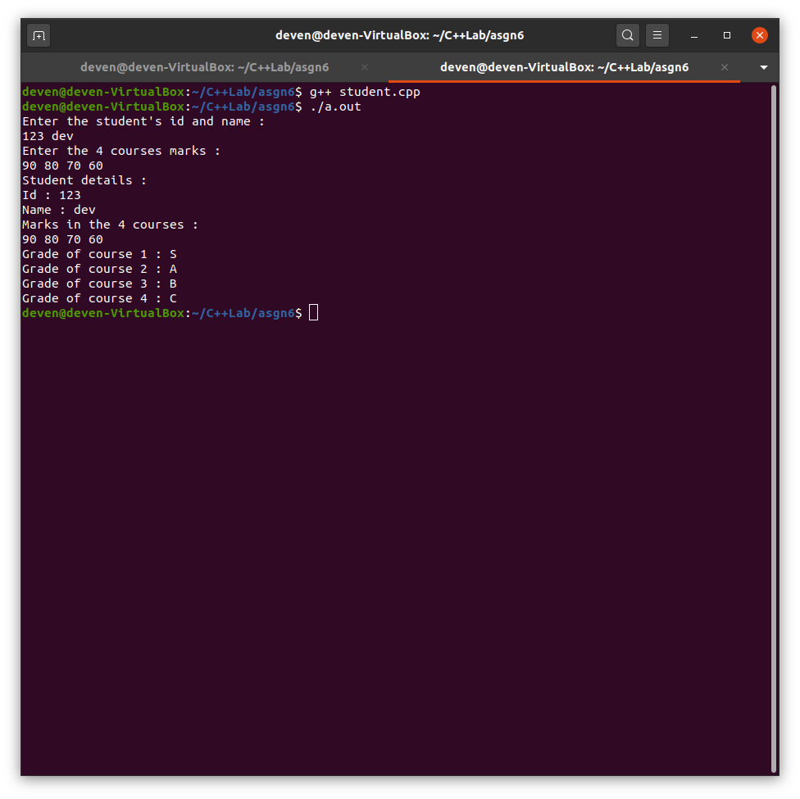

4. Prepare a class Hexa and a class Oct with suitable attributes and member

functions. Add a friend function Convert to convert the numbers (both the

classes) into Decimal format.

#include <iostream>

using namespace std;

class Hexa

{

private :

string number;

public :

Hexa(string n = "0") : number(n) {}

void read()

{

cout << "Enter a Hexadecimal number : ";

cin >> number;

}

void display(){ cout << "The Hexadecimal number is : " << number << endl; }

friend int toDecimal(Hexa);

};

class Oct

{

private :

int number;

public :

Oct(int n = 0) : number(n) {}

void read()

{

cout << "Enter a Octal number : ";

cin >> number;

}

void display(){ cout << "The Octal number is : " << number << endl; }

friend int toDecimal(Oct);

};

int toDecimal(Hexa h)

{

int len = h.number.size();

int base = 1; // 16^0 = 1************************************

int decimalNum = 0;

for(int i = len-1; i >= 0; --i)

{

if(h.number[i] >= '0' && h.number[i] <= '9')

decimalNum += (h.number[i] - '0') * base;

else//if(h.numer[i]>='A' && h.number[i]<='F')

decimalNum += (h.number[i] - 'A' + 10) * base;// or use pow();

base *= 16;//base is 16, so 16^0, 16^1, 16^2 etc

}

return decimalNum;

}

int toDecimal(Oct o)

{

int base = 1;

int decimalNum = 0;

int octalNum = o.number, rem;

while(octalNum != 0)

{

rem = octalNum % 10;

decimalNum += (rem * base);

base *= 8;

octalNum /= 10;

}

return decimalNum;

}

int main()

{

Hexa h;

h.read();

h.display();

cout << "The decimal form of this number is : " << toDecimal(h) << endl;

Oct o;

o.read();

o.display();

cout << "The decimal form of this number is : " << toDecimal(o) << endl;

return 0;

}

